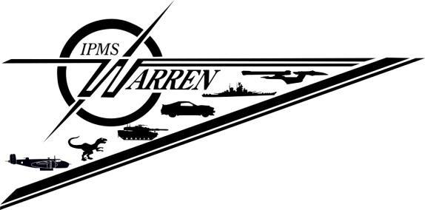

**Presents**

SEMMEX Saturday, February 15th,2025

**Walter F. Bruce VFW Post 1146**

**28404 Jefferson Ave.**

**St. Clair Shores, MI 48081**

**Theme: 1965**

Registration Fee: Adult - $10, includes first **3** models. $1 for each additional model

Junior Registration (16 and Under) - $8, unlimited number of entries

General Admission - $5, 13 and Under Free

Vendor Tables - 8’ x 30”, **$30** each

**Information Contact Vendor Contact**

Jim Ashford Ron Harris

248-574-3487 harrisron1991@gmail.com

jimandkatie17@att.net

**Visit our website, www.ipmswarren.com for further information and registration forms   
Nick Vanston  Memorial Award**

Best Military Engineering Vehicle

wheeled or tracked All countries

WWII to present.

 (Sponsored by Motor City Armor and Figure Society)